Tasks: To find out Defects

**Defect ID #1:**

Title: Number of cases displayed is incorrect

Steps to reproduce the issue:

Navigate to Finding the truth

URL: <https://learning.elucidat.com/course/5c9126fd760e5-611a53751213a>

Use start button to explore cases

Click start and verify the number of cases displayed

Expected : 3 cases should be displayed for user to select

Actual: Only 2 cases displayed

Please see the below screenshot for reference:

Explore cases images:

Hamburger Menu image: Only 2 cases displayed here

**Defect ID #2:**

Title: Incorrect video is displayed

Steps to reproduce the issue:

Navigate to Finding the truth

URL: <https://learning.elucidat.com/course/5c9126fd760e5-611a53751213a>

Use start button to explore cases

Select “Who is to blame?”

And verify the video displayed

Expected Behaviour: WHAT HAPPENED?” item in the hamburger menu should be displayed

Actual: Making a case against Kevin case video is displayed

Please see the below screenshot for reference:

Hamburger Menu image: Expected behaviour

**Defect ID #3:**

Title: Incorrect verdict is saved

Steps to reproduce the issue:

Navigate to Finding the truth

URL: <https://learning.elucidat.com/course/5c9126fd760e5-611a53751213a>

Use start button to explore cases

Select “Making a case against Kevin”

And Select “Judge This”

And select Guilty and Vote

Verify the confirmed details in popup window

Expected Behaviour: The guilty verdict should be confirmed and displayed in popup window

Actual: Not Guilty verdict is displayed in the popup window

Please see the below screenshot for reference:

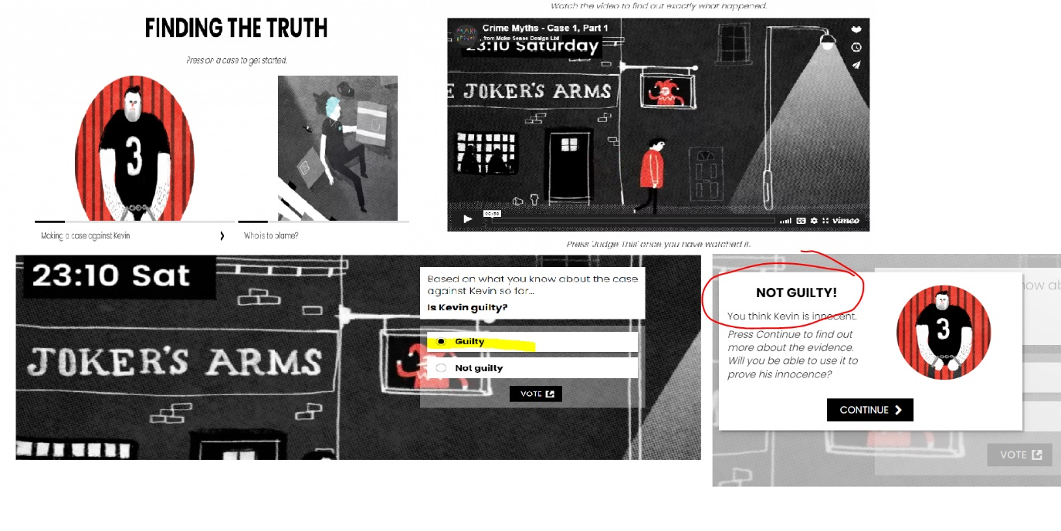

**Defect ID #4:**

Title: Scores displayed as todays date

Steps to reproduce the issue:

Navigate to Finding the truth

URL: <https://learning.elucidat.com/course/5c9126fd760e5-611a53751213a>

Use start button to explore cases

Expected: Score should be an integer value

Actual:

Scores displayed as today’s date, e.g. “Your score so far:06/07/22”

**Defect ID #5:**

Title: User cannot navigate back to Initial start page

Steps to reproduce the issue:

Navigate to Finding the truth

URL: <https://learning.elucidat.com/course/5c9126fd760e5-611a53751213a>

Use start button to explore cases

And close the browser and open the Url again to navigate to start page

Expected: User should be landing on the start Page

Actual: User is not able to navigate to start Page as the session is not getting expired soon

**Defect ID #6:**

Title: Hamburger menu is not visible in all pages

Steps to reproduce the issue:

Navigate to Finding the truth

URL: <https://learning.elucidat.com/course/5c9126fd760e5-611a53751213a>

Use start button to explore cases

Select “Making a case against Kevin”

And Select “Judge This”

And select Guilty and Vote

Expected: Hamburger menu is visible   
Actual: Hamburger menu is not visible

**Other issues observed:**

* “Case Study: Eyewitness”
  + Background colour is inconsistent when compared to other case studies

Broken links:

* From Hamburger Menu navigate to “Final Verdict / Real Life Example / HSE Report” and click the Löfstedt review
  + Link is broken
  + Link name not displayed with special characters

* “Final verdict”
  + Account public votes does not matches in the pie chart

